Shopping Cart System

A Project Report

Submitted by

Bhavya Joshi (179302043)

Anshika Goel (179302023)

In partial fulfilment for the award of the degree

of

BCHELOR OF TECHNOLOGY

IN

Information Technology

At



MANIPAL UNIVERSITY JAIPUR

JAIPUR

April 2019
DECLARATION BY THE CANDIDATES

I hereby declare that the work, which is going to be presented in the Project, entitled “Shopping Cart System” to be submitted in partial fulfilment of the requirement for the award of Degree of “Bachelors of Technology” in Department of Information Technology with Specialization in Microprocessor and Microcontroller and to be submitted to the Department of Information Technology, Manipal University Jaipur is an authentic record of my own investigations carried out under the supervision of Dr. Vivek K Verma , Assistant Professor, SCIT, Manipal University Jaipur.
I have not submitted the matter presented in this project anywhere for the award of any other degree.

Bhavya Joshi
179302043

Anshika Goel
179302023

ACKNOWLEDGEMENT

The enduring pages of the work are the cumulative sequence of extensive guidance and arduous work. I wish to acknowledge and express my personal gratitude to all those without whom this work could not have been reality.

I feel very delighted to get this rare opportunity to show my profound senses of reverences and indebtedness to my esteemed Dr. Vivek K Verma for his keen and sustained interest, valuable advice, throughout the course of which led my report, to a successful completion. For this kind act of consideration, I be holder to him in special manner and no one can fully convey my feelings of respect and regard for them.

LIST OF FIGURES

Figure 1.1 | First Screen | 3
Figure 2.1 | Instruction Screenshots | 7
Figure 2.2 | Screenshots of Flow | 12
Figure 2.3 | Final Result | 13

TABLE OF CONTENTS

PARTICULARS |  |  | Page
Candidate’s Declaration |  |  | ii
Acknowledgement |  |  | iii
List of Figures |  |  | iv
Abstract |  |  | 1
1 | Introduction |  | 2
 | 1.1 | Background | 2
 | 1.2 | Project Motivation | 2
 | 1.3 | Aims and Objectives | 2
 | 1.4 | Implications | 4
2 | Implementation |  | 5
 | 2.1 | Tools & Technology | 5
 | 2.2 | Description | 6
 | 2.3 | 8086 Instruction Used | 12
3 | Conclusion |  | 11
References |  |  | 11

ABSTRACT

The aim of the project is to understand the various instructions taught to us during class and with them create a practical example wherein we use these instructions to carry out something practically implementable in real life. Through this we learned the exact use of the instructions in real life based logic and programs.

Chapter - 1
INTRODUCTION
  - Background
The challenge was to be able to implement a usually high level language code to a basic assembly language code and have various inputs taken from the user, and on that basis implement a choice based shopping system.
1.2 Project Motivation
As a user of everyday shopping sites like Amazon we were curious to see how we could implement a choice based shopping cart system through assembly language programming.
1.3 Aims and Objectives
- Identify, understand, and practically implement instruction sets
- Explore how to use course based knowledge in real world
- To be more real world application oriented rather than focusing on just the theory

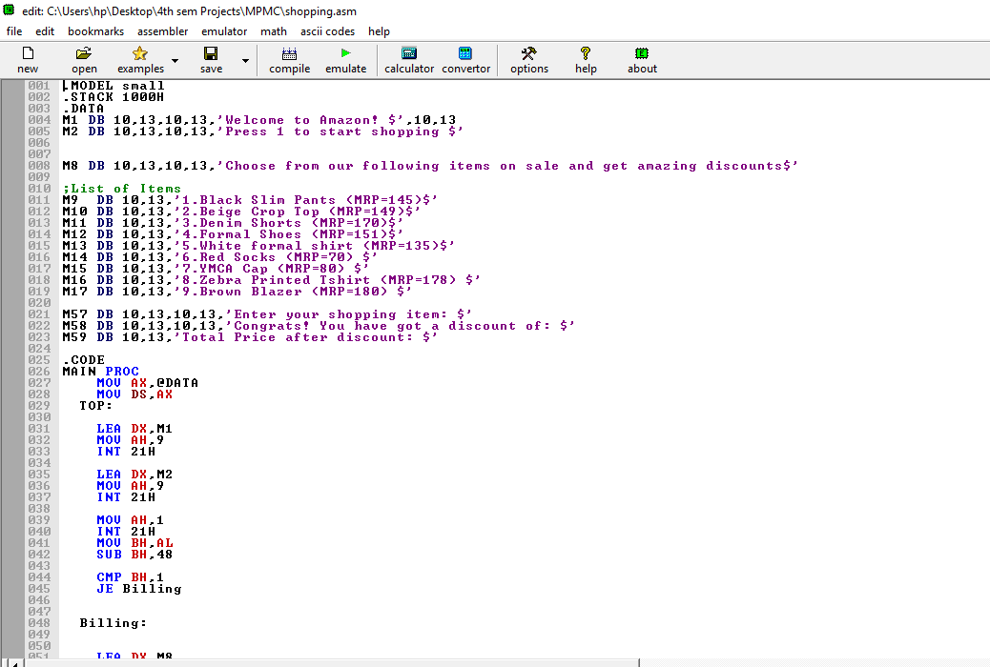
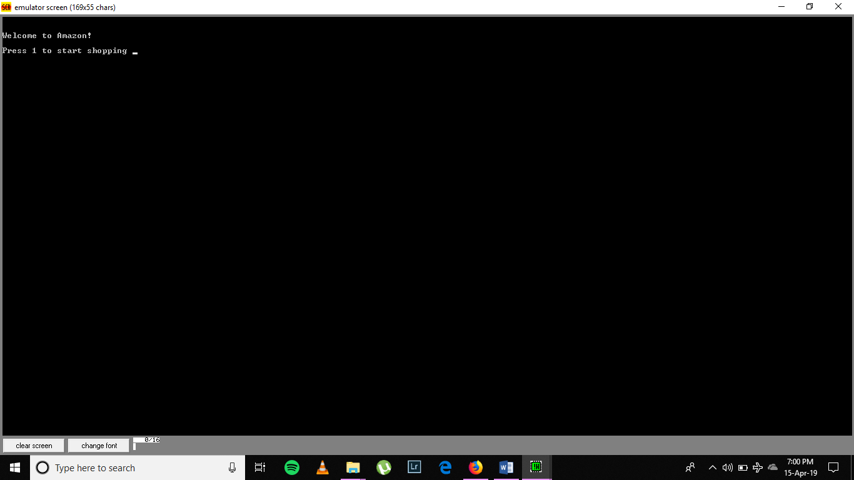

Figure 1.1: First Screen

1.4 Implications in system development
This project helps to understand the complexity of web based sites like Amazon and Flipkart and understand how these real world systems work to ease the lives of various people today and how convenient they make a basic need like shopping.

Chapter - 2
IMPLEMENTATION
2.1 Technology Used
The logic for this project was based around comparing and performing appropriate instructions specified for that particular choice. This was done using 8086 instruction set using the 8086 emulator.

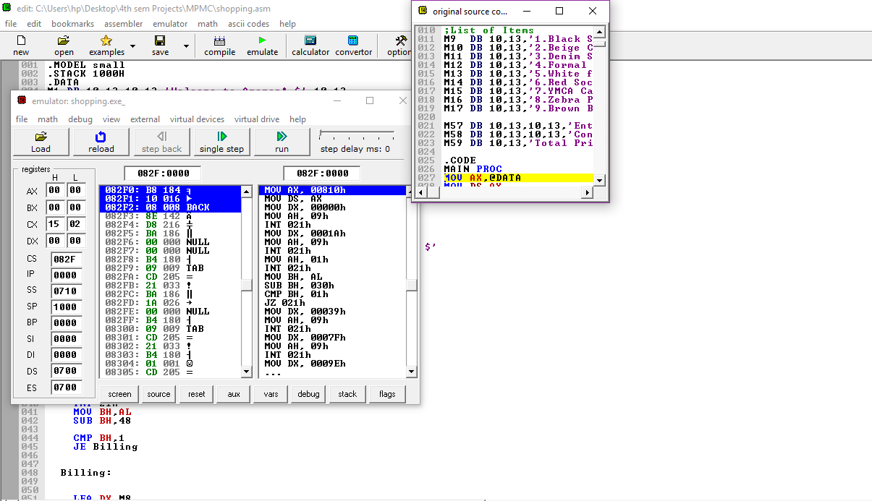

2.2 Description
- This project starts with asking the user for input and if the user presses 1, the shopping cart displays on the screen.
- The shopping cart contains various items listed along with their MRPs. All the items in the cart also have a surprise discount offer.
- The program then asks the user to choose from the listed items. These choices have a separate statement block that is executed like if then block.
- Using comparison, the user’s choice is considered and the appropriate block of code is executed.
- Then using various instructions to convert number to ascii and vice versa the appropriate discount amount is displayed on the screen along with the final price of the item.
- Thus it implements a choice based shopping cart system which shows final prices and discount amount.

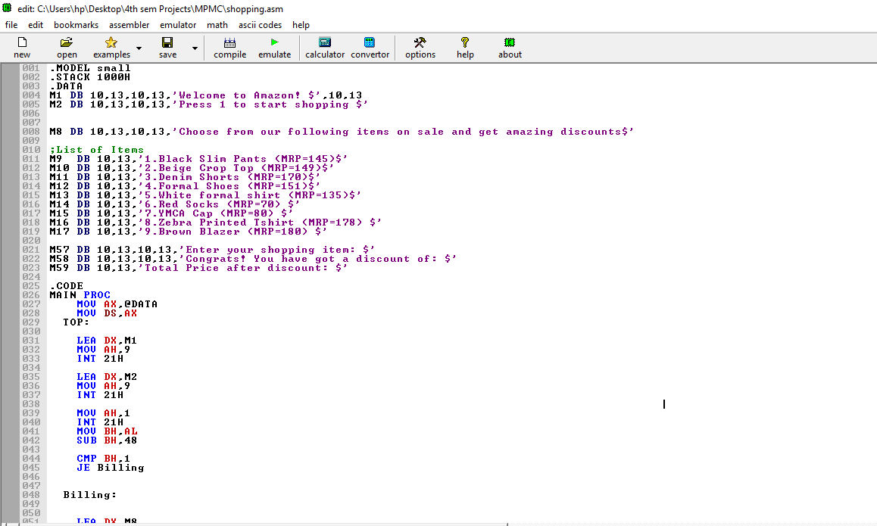
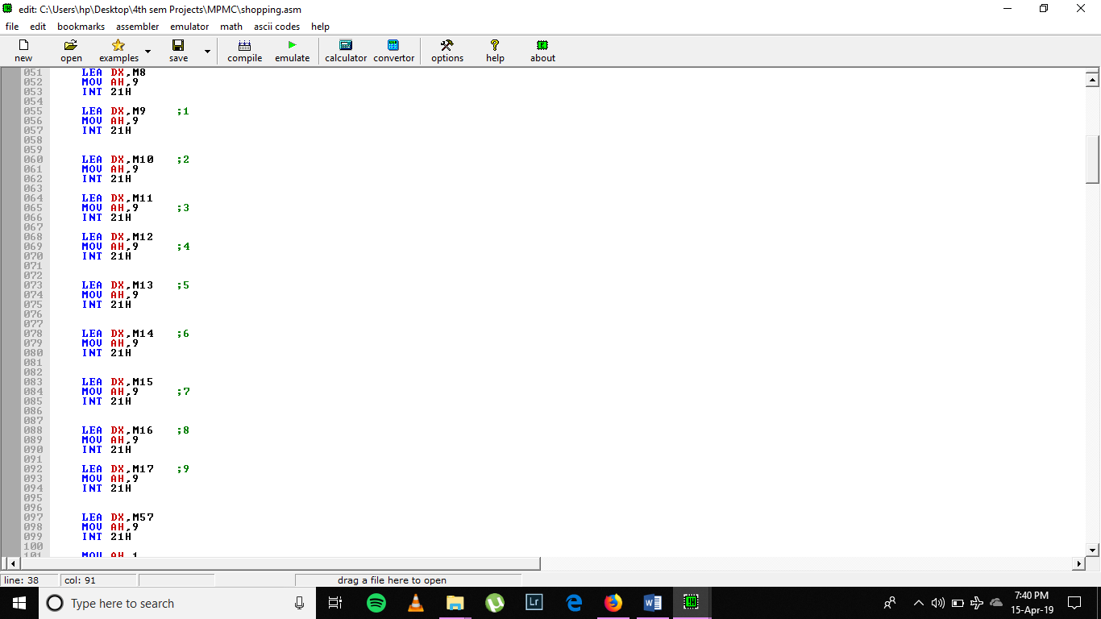

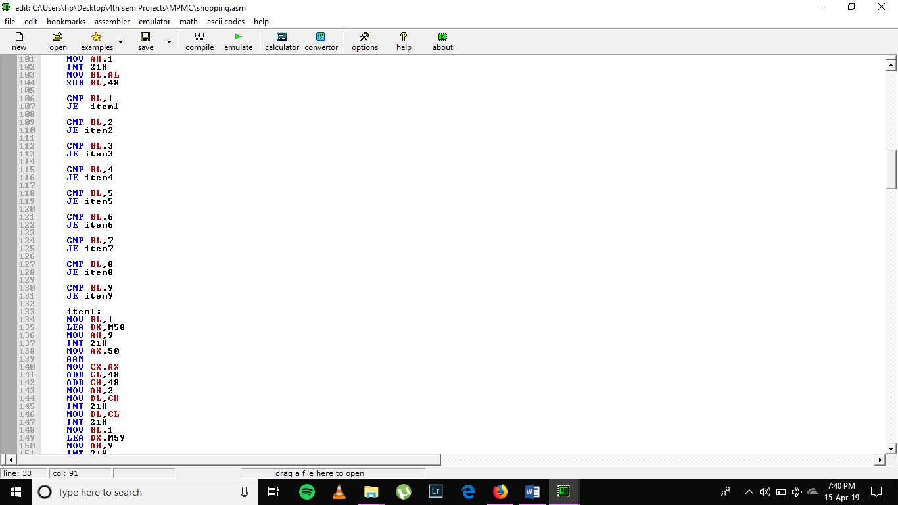
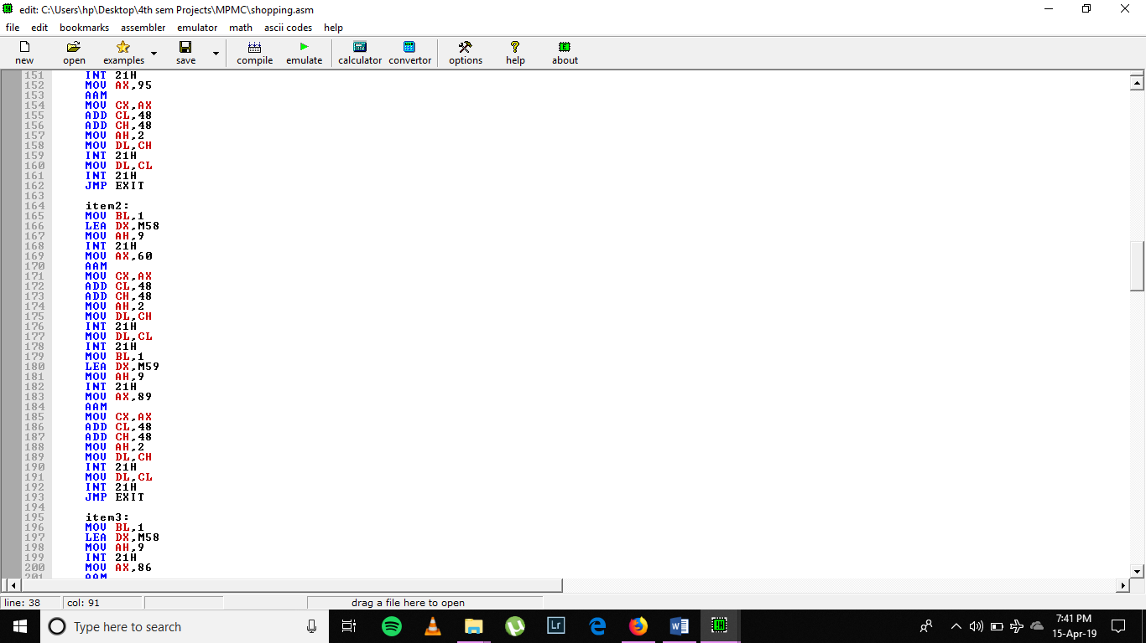
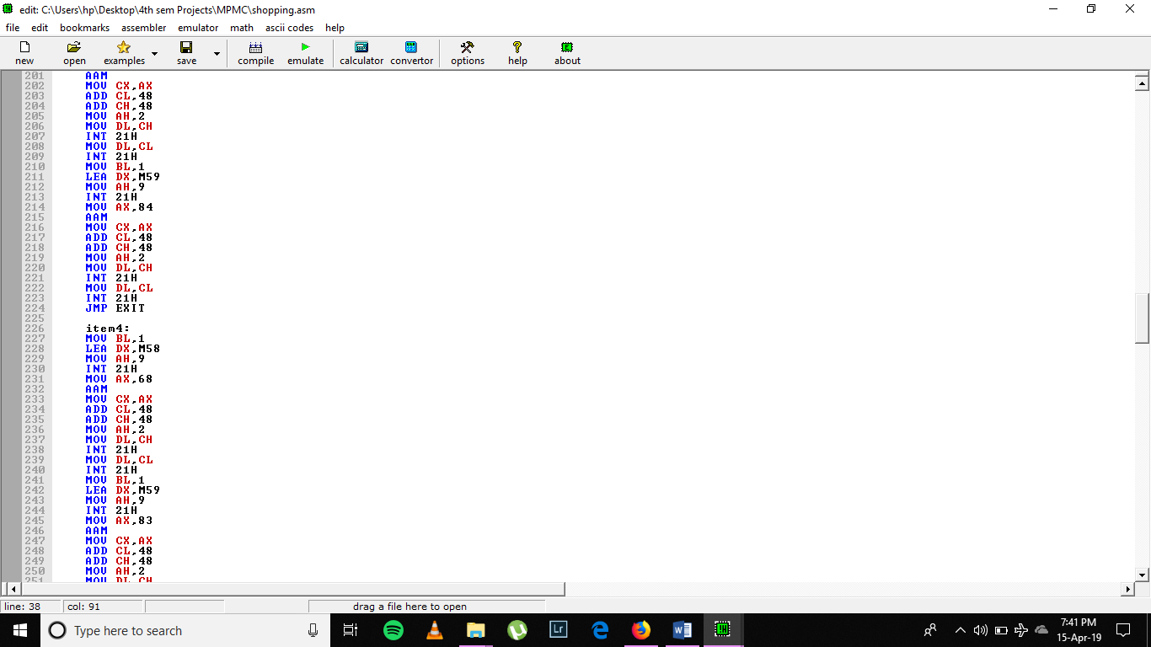
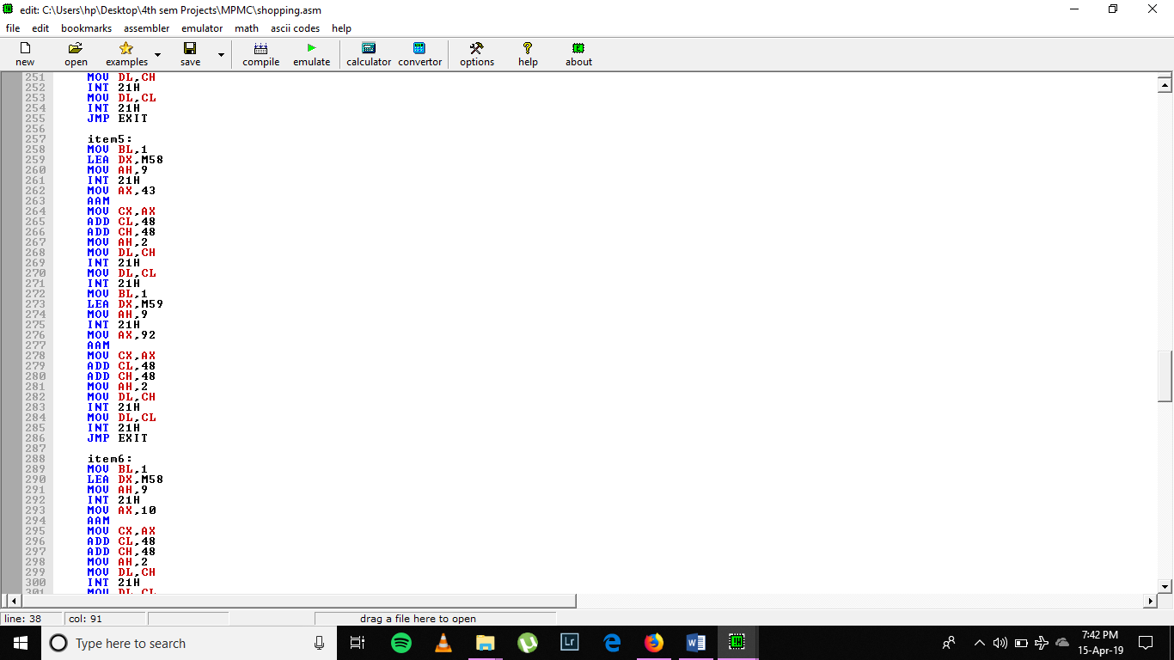
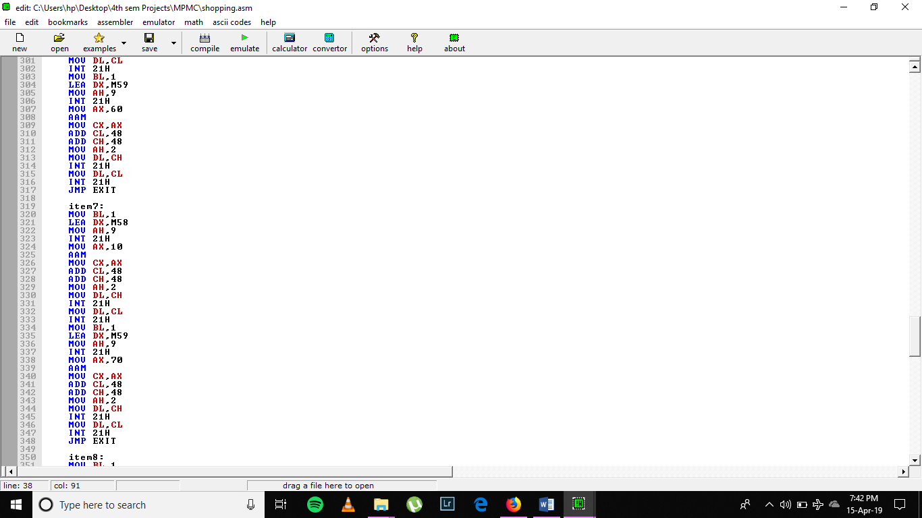
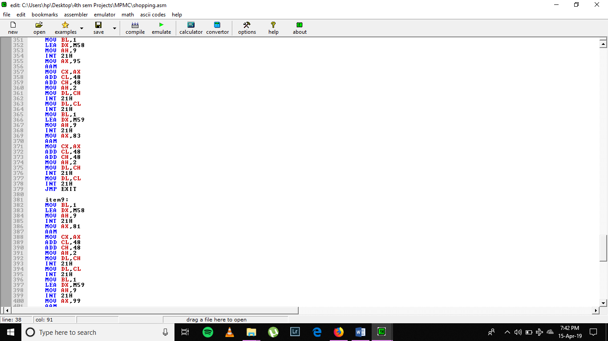
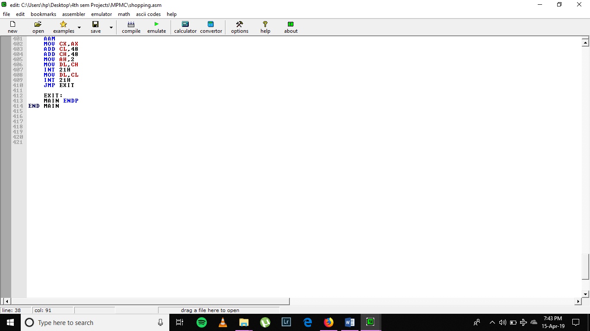

2.3 Instructions Used
We used the following instructions in the project:

- MOV − Used to copy the byte or word from the provided source to the provided destination
- LEA – Used to load the Effective Address
- INT – Used to generate a software interrupt for input and output
- PROC – Used to define a procedure
- SUB – Used for subtraction
- CMP – Used to compare two values used subtraction
- JE – Used to jump to a label if the values are equal
- AAM – Used to adjust Ascii adjust AX to create two unpacked decimal digits
- ADD – Used to add two values
- JMP – Used to unconditionally jump to a label
- ENDP – Used to end the program

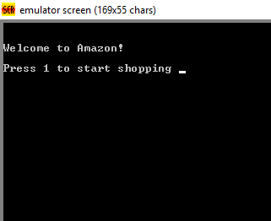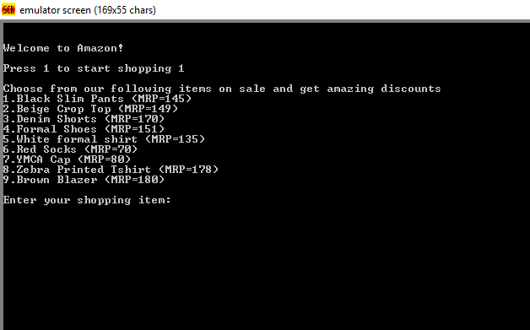
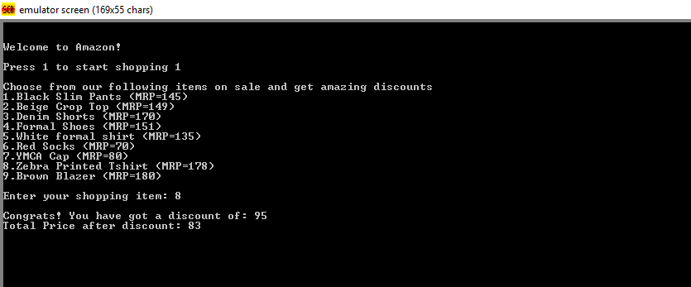
Chapter - 3
CONCLUSION
The conclusive result is based on user’s choice entered through the keyboard and converted to packed digits by which comparison is made. Thus this project helps to implement a real world problem which we use every day in the form of simple machine level code utilizing basic instruction set.

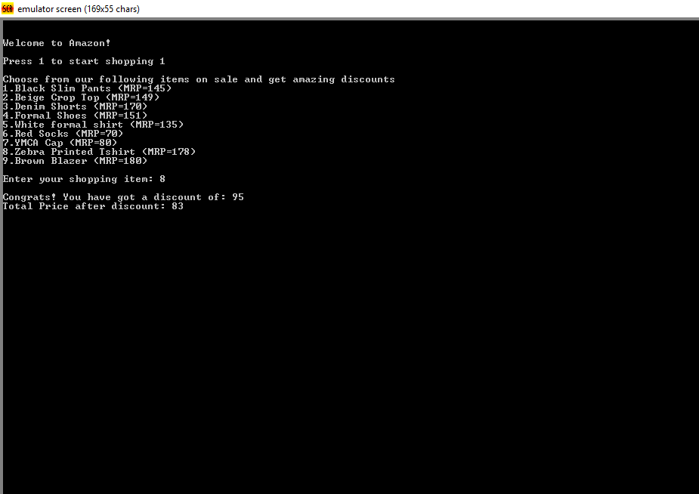

REFERENCES

Web

[1 https://www.felixcloutier.com/x86/
[2] https://www.youtube.com/
[3] https://www.tutorialspoint.com/microprocessor/microprocessor_8086_instruction_sets.htm

